Red Cabbage Lab: Acids and Bases
Introduction:
Liquids all around us have either acidic or basic (alkaline) properties. For example, acids taste sour; while, bases taste bitter and feel slippery. However, both strong acids and strong bases can be very dangerous and burn your skin, so it is important to be very careful when using such chemicals. In order to measure how acidic or basic a liquid is, one must use the pH scale as illustrated below:
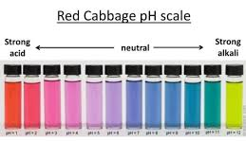
The strength of the pH scale is determined by the concentration of hydronium ions (H₃O⁺) where a high con centration of H₃O⁺ ions indicate a low pH and a low concentration of H₃O⁺ ions indicate a high pH. The pH scale ranges from 1 to 14 where 1 to 6 is classified as acidic, 7 neutral (neither a base or an acid) and 8 to 14 is classified as basic.

In this lab, you will use the juice from red cabbage as a pH indicator to test common household liquids and determine their pH levels. You will mix cabbage juice with different household liquids and see a color change produced by a pigment called flavin (an anthocyanin) in red cabbage. Through this color change, you will be able to successfully identify the approximate pH of common household liquids using the table below:

Color: | Dark Red | Pink | Violet | Blue | Blue-  Green | Green-  Yellow
Approx.  pH | 1-2 | 3-4 | 5-7 | 8 | 9-10 | 11-12
Acid/  Base | Acid | Acid | Acid/Neutral | Base | Base | Base
Materials:
Pre- Cut Cabbage Blender or Juicer
Strainer
Large Container
7 plastic cups
7 plastic spoons
Compounds to Test: (If you do not have these, use any items that might be acidic or basic, do seven total.)
Liquids Solids (dissolve in water first)
- White Vinegar Baking Soda
- Apple Juice Tums (or any antacid)
- Shampoo (preferably clear) Aspirin (or other pain killer)
- Conditioner (preferably clear) Powdered cleanser
- Hand Sanitizer Powdered detergent
- Lemon Soda Table salt
- Lemon Juice

Preparing the Cabbage Juice :
- Put the red cabbage leaves into the blender with 3 cups of water.
- Close the top and let it blend at high power for 30 seconds.
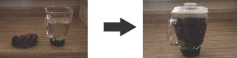
- Once it is blended, filter out the leaves inside the mixture with the strainer and pour the mixture into a large container.
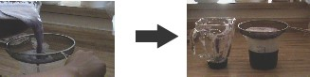
*This should provide you with 2-3 cups of cabbage juice.

If you don’t have a blender, you can heat the cabbage:

WHAT YOU NEED TO MAKE A RED CABBAGE INDICATOR
- A grater
- Red cabbage
- Hot water
- A saucepan
- A sieve
- Grate the cabbage.
- Place into a saucepan and pour in 3 cups of boiling water from the kettle.
- Heat until simmering and leave for 10 minutes.
- Sieve the water and cabbage into a jug – you will notice that the cabbage liquid is very purple in color.
- Leave to cool for about 30 minutes and the indicator is ready to use.

Mixing the Cabbage Juice:
- Label each cup with each of the liquids. (Example: vinegar, apple juice, etc.)
- Pour ½ cup of each individual liquid into its respective cup

- For solids, add 3 teaspoons of solid into ½ cup of water.
Example:
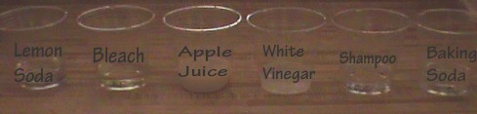
- Pour ¼ cup of cabbage juice into each of the plastic cups. Do this one at a time and record the color change on next page.

Liquid: | Color Change | pH | [H₃O⁺] | [OH⁻]
Hand Sanitizer
Lemon Soda
Apple Juice
White Vinegar
Shampoo
Conditioner
Solids:
Baking Soda
Tums (or any antacid)
Aspirin (or other pain killer)
Powdered cleanser
Powdered detergent
Table salt

- Categorize your results below:

Very Acidic | Acidic | Neutral | Basic | Very Basic

- Now add 3 teaspoon of solid baking soda into each cup and stir.

Does the color of the solution change? If so, how and why do you think this is?

Concept Questions:

- Does the addition baking soda +water alter the pH of weak acids/bases? How does it change the pH of strong acids/bases? Why or why not?

- How does a difference in 1 pH unit change in terms of H+ concentration? Example: How does a pH of 3 differ from pH of 4? Which one is stronger or weaker? Why?

- Look at the ingredients for each liquid you tested. Which ingredients contribute to each of the liquid’s pH level?

Real Life Applications:

- Neutralization: Whenever you mix an acid with a base, they neutralize each other. If this is the case, why is Alka- Seltzer used to treat stomach aches? (Note: excess stomach acids cause stomach aches)

- Acid Rain: What is acid rain and how is it a problem to oceans, rivers, lakes, ponds etc

